Nesting questions using XML Spy tool
Greensheets

Version 1.0
Revision History
Date | Version | Description | Author
29/Dec/2008 | 1.0 | Initial revision. | Anatoli Kouznetsov

Table of Contents
1. Introduction 3
1.1 Purpose 3
1.2 Scope 3
1.3 References 3
2. Background 3
3. Step-by-step instructions 4

Greensheets
Nesting questions using XML Spy tool

Introduction

Purpose
The purpose of this document is to provide illustrated step-by-step instructions on how to use XML Spy tool to edit a Question Definition XML file for Greensheets to "nest" certain questions inside <SelectionDef> elements of other questions, thus creating Greensheets' "question hierarchy," which makes it possible for some "follow-up questions" to "unfold" if Greensheets user chooses one answer to the "initial" question, and different follow-up questions if the answer the user chose for the "initial" question was different.

Scope
This document was written to assist the team maintaining the Greensheets system at the National Cancer Institute. It is however, generally applicable to editing XML files where elements can be "nested" inside other elements.

References
Refer to a wide array of documentation about the Greensheets system available at the following base URL:
https://subversion.nci.nih.gov/svn/iscs/greensheets/

Background
The essence of the Greensheets system functionality is enabling users to fill out electronic, web-based interactive questionnaires. "Interactive" means that initially, a user is presented with a certain, relatively short, list of questions, and depending on which answer the user chooses for each question, the system may show one set of follow-up questions or another (or none at all).
What questions will be displayed on Greensheets questionnaire forms is defined in "Question Definition XML files" that follow a particular XML schema. Inside such an XML file, questions that are not "initial" (top-level) questions but rather follow-up questions, should be nested within the definition of their "parent" question, and more specifically, within the <ResponseDef><SelectionDef> element describing the specific answer choice that makes the follow-up question relevant. With respect to formatting the XML file, this means that it is desirable to have definitions of follow-up questions strongly indented to the right within their "parent" XML element.
In theory, taking an XML tag (and its nested tags) and nesting it within a different tag, including the appropriate indentation within the XML file, should not be a big deal – it is possible to do it using Notepad or any text editor software. However, in practice this task becomes labor intensive and error-prone due to the large size of the XML tag defining each question. A single question – before any follow-up questions are nested inside it! – can be 480 lines long. Cutting, pasting, and indenting such long blocks of text in a "simple" text editor can be difficult because it is hard to see the high-level view of the XML file's structure and it's too easy to "get lost" inside the file of that size (where all the lines look so similar for pages on end!). This can easily lead to placing blocks of XML in wrong locations.
This is why the team maintaining the Greensheets system acquired the tool called XML Spy. A copy of installation media is located at:
\\nci6116a.nci\nih.gov\group\Number6\Software for NCI Projects\XML Spy 4.4
The beauty of XML Spy is that it allows you to "collapse" the entire 480-lines-long tag, with all of its nested tags, into a compact "object" that you can copy-paste and drag-and drop. It also supports rendering the data contained in an XML file in tabular format, including nested tables, and copy-pasting between and within the rows, columns and cells of that "table view".
The remainder of this document provides step-by-step instructions, with screenshots, for taking an XML tag that initially represents a top-level question (question B), and nest it within the answer choice of a different question (question A), where Question B is actually supposed to be a follow-up question to question A.

Step-by-step instructions
These instructions assume that you have successfully produced the XML file with definitions of all questions, all tags, all answer choices, etc., the file is valid for Greensheets' XML schema, but all questions are at the top-level – and the only thing remaining to do is to "nest" follow-up questions inside the respective answer choices of their parent questions.
- Start XML Spy, load the file we will be editing, and switch to the "Enhanced Grid View" unless that's the view you are in from the beginning (View menu on the menu bar).
- By expanding the "table/cell" representations of XML tags in the Enhanced Grid view, locate the parent question, and the specific answer choice (in other words, <SelectionDef> element) within which the follow-up question will have to be nested.
- With <SelectionDef> element (inside which the child question should be nested) highlighted, right-click with the mouse, and from the pop-up menu, choose "Add child → Element" – see the screenshot below. It is very important to have exactly the right item highlighted in the complex grid structure.
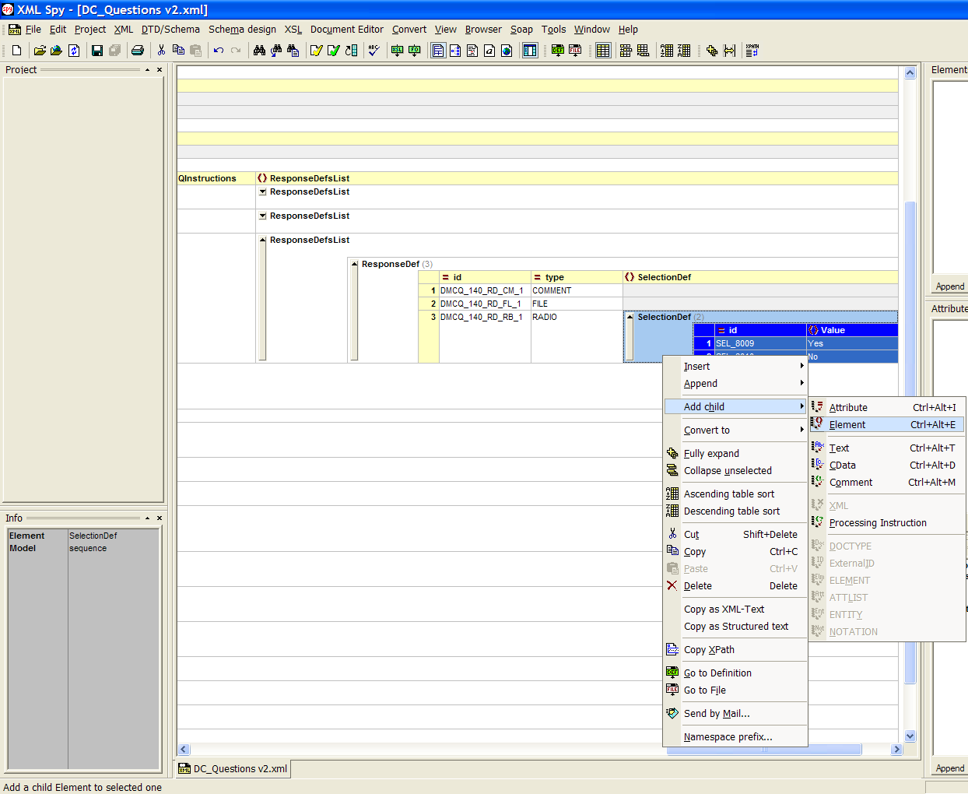
- XML Spy will ask what kind of child element you would like to add – it will show a drop-down list displaying the kinds of elements that are valid for this location according to the XML schema for the file being edited. In our case, the valid choices are <QuestionDef> and <Value>. See the screenshot below. Choose QuestionDef.
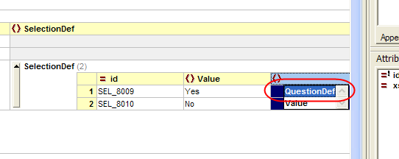
- This will result in a blank, empty <QuestionDef> element being added inside the <SelectionDef> of the parent question. It will be appropriately nested, and when you eventually switch to plain-text view of the XML file, it will be appropriately indented. In the next couple of steps, we will use cut-and-paste to replace this blank <QuestionDef> at its proper nested location with a non-empty <QuestionDef> containing the follow-up question.
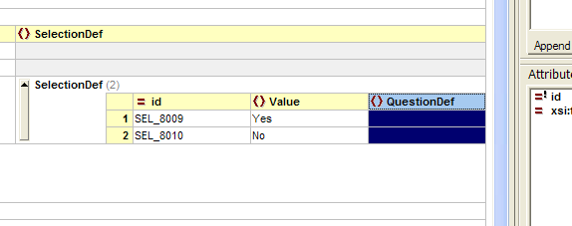
- Locate in the XML file (in its "grid view" representation) the question that will be the actual child question that should be moved to the location where you just created the blank question. Right-click on the margin on the left-hand side to highlight the entire data row with that question, and select "cut" from the pop-up menu. See the screenshot below.
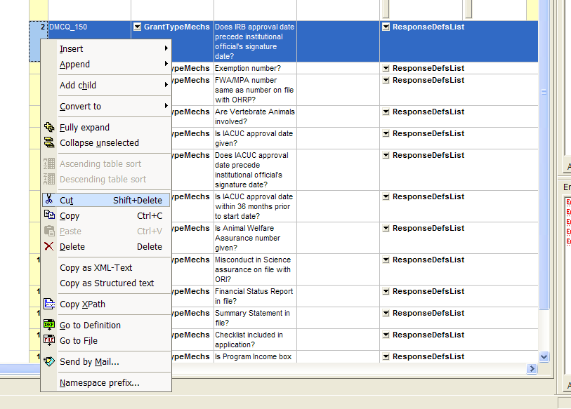
- With the content of the entire tag defining the follow-up question now in clipboard, return to the blank nested child QuestionDef element you just created. Highlight the "cell" that corresponds to the QuestionDef element within the <SelectionDef> tag whose value is "Yes" (if this is the answer for which the follow-up question in the clipboard is relevant). It is very important to highlight just that cell, as shown on the screenshot below, and not the whole row or the whole column or the whole <SelectionDef> element or anything else.
Right-click in the highlighted cell, and select Paste from the pop-up menu.
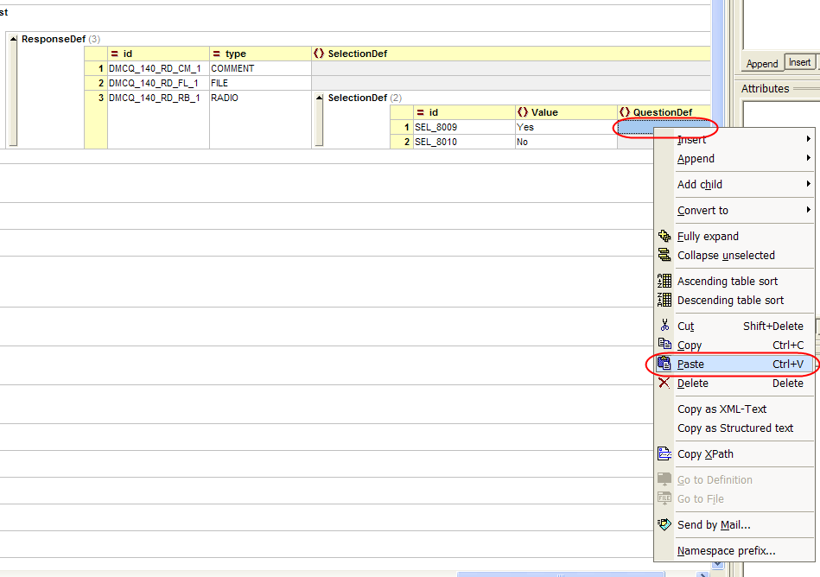
- If there are additional follow-up questions that should be asked once the user chose the same answer to the same initial question (i.e., the same answer requires asking several consecutive follow-up questions), then the process for nesting the remaining, additional questions within the same <SelectionDef> is a little different. Again, locate the next follow-up question that for now is set up as a top-level question, but actually should be nested within the same <SelectionDef>. Left-click on the left margin to select the entire row, hold the mouse button down, and begin to drag it – the display should begin to look as in the screenshot below:
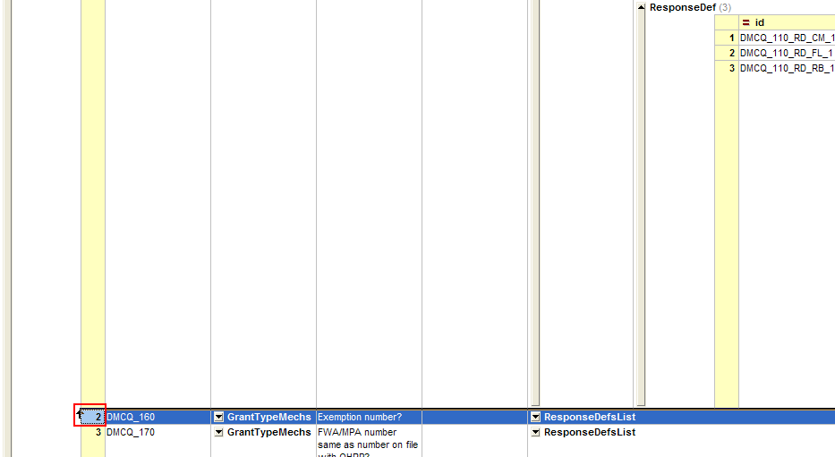
- Keep on dragging the question towards the <SelectionDef> inside which it should be nested, and position the mouse pointer over the left-margin selector of the "first" follow-up question that you just nested. You need to see the down arrow and the thick black vertical line exactly as in the screenshot below. It that point, "drop" the question by releasing the left mouse button.
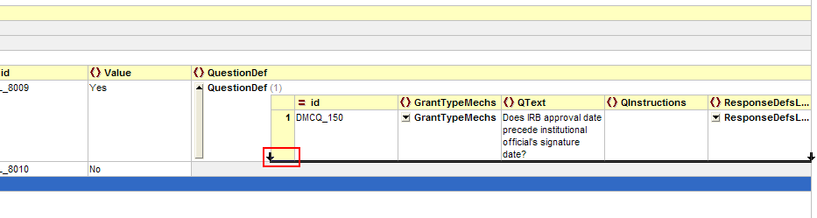
- As a result, the next child question will be inserted directly below the first child question – still nested within the same <SelectionDef> element of the parent question. See the screenshot below to see what it looks like.
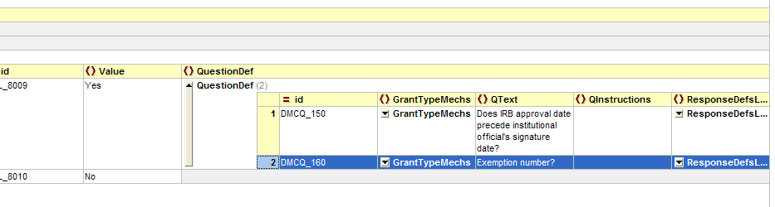
- At this point, if you switched to Text View, you would see all questions neatly indented as expected. Proceed with nesting the remaining questions. Remember to save the file often.

